LMS Online Quiz - Quiz Preview

After creation of the quiz and adding questions to the quiz. Teachers can preview the quiz to get an idea of how the quiz will appear to the students.
- Open the quiz summary page.
- Click on the “Actions Menu” icon and choose “Preview” from the dropdown menu.
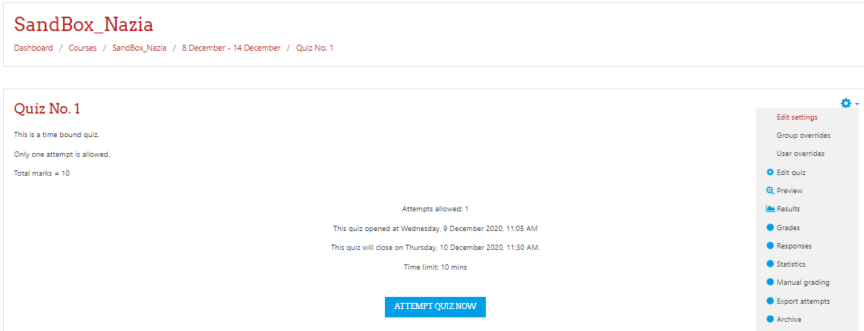

- Click on the “Start Attempt” button (Preview page displays the student view of the quiz to the teacher.
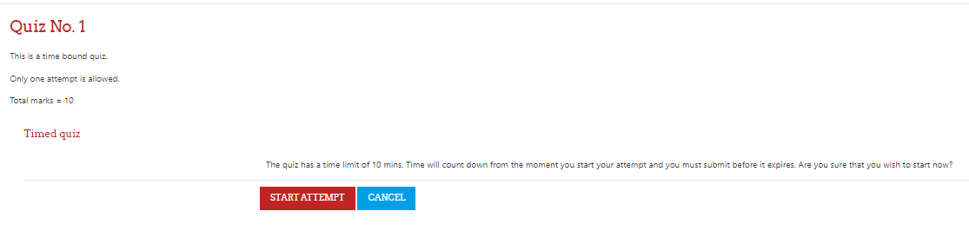
- Quiz preview starts with a “Quiz navigation” block on the right side of the page, showing a countdown timer and questions links.
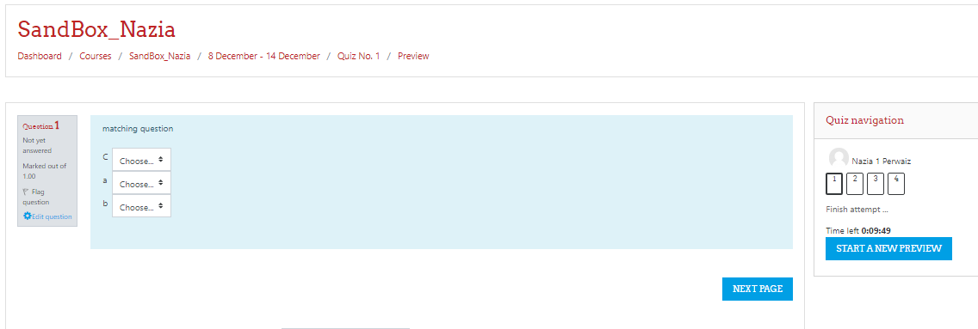

- The navigation block shows the quiz progress to the students, attempted questions are turned to half shaded rectangles, incomplete answers have a red flag on it and unattempted questions have white background.
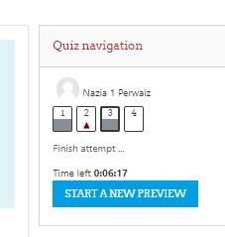
- After completing the quiz, a summary statistics of the attempt appears to the student with the links whether to return to the quiz attempt or finish the quiz.
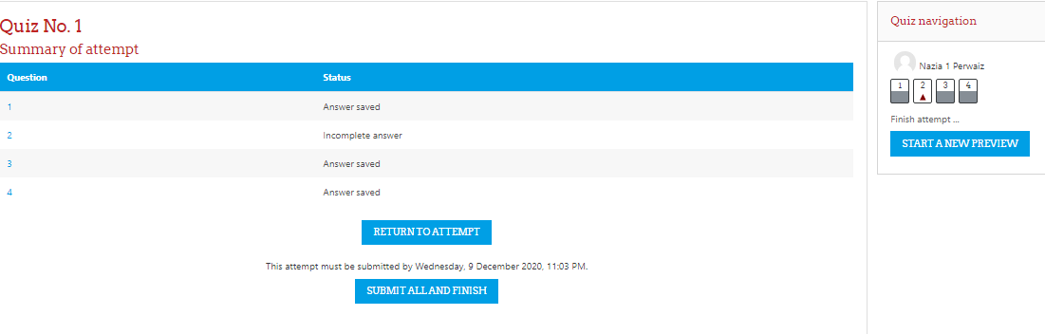

- After confirmation message students can submit the quiz.

Note: If you have selected “open attempts will be submitted automatically” for the setting of “When time expires” in the Quiz settings. The incomplete or non-submitted quiz attempts would be automatically submitted and graded.

______________________

